Cooperative Summer School
Batch Report Card Printing

Step 1: Login
School Tool login information:
- Enter your Username – home district email address
- Enter your Password – Emailed to you from SchoolTool (can be changed once you are logged in)
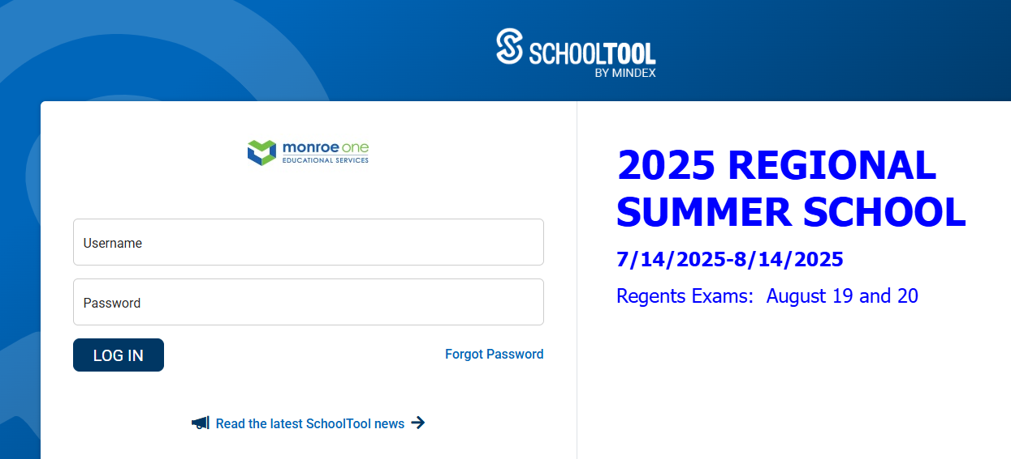
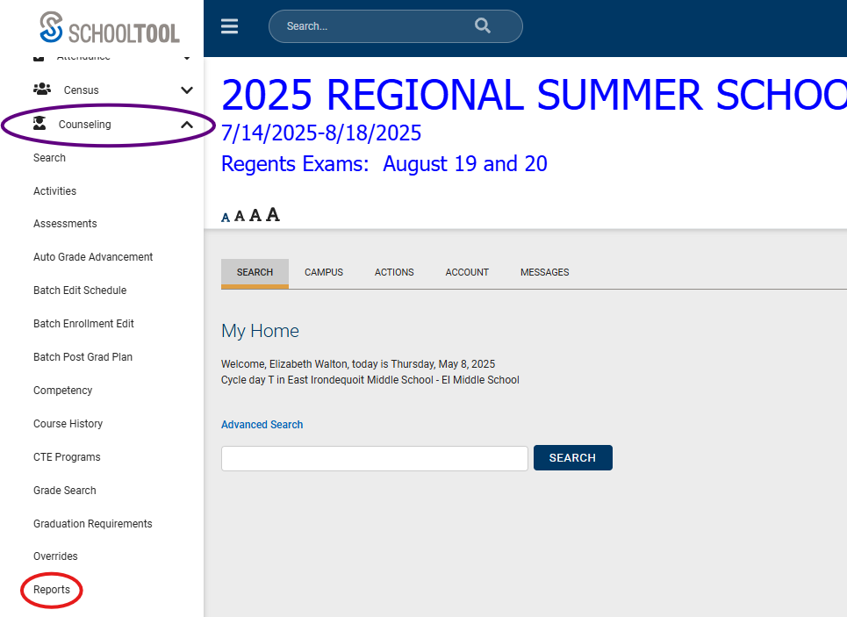
Step 2: Counseling Module
- Select the Counseling module in the left menu
- Under the Counseling module heading, select “Reports”

- In the Reports Listing, find Report Cards and click >
- In “Add Search Criteria” select “Home District. Then select your district/building from the Home District dropdown menu
- Click “SEARCH” button at bottom
- Export and print schedules

